**APPENDIX 1**

**TELEMEDICINE: EMPOWERING EMERGENCY DERMATOLOGY CARE WITH A CONSULT MOBILE APPLICATION**

**A PROJECT REPORT**

***Submitted By***

**VARSHINI D**

**MOHANA PRIYA S**

**AKASH R**

**SHARMILA T**

***in partial fulfillment for the award of the degree***

***of***

***BACHELOR OF ENGINEERING***

***IN***

COMPUTER SCIENCE AND ENGINEERING

**KARPAGA VINAYAGA COLLEGE OF ENGINEERING AND TECHNOLOGY**

**ANNA UNIVERSITY:: CHENNAI 600 025**

MAY 2025

**APPENDIX 2**

**ANNA UNIVERSITY: CHENNAI 600 025**

**BONAFIDE CERTIFICATE**

Certified that this project report **“TELEMEDICINE : EMPOWERING EMERGENCY DERMATOLOGY CARE WITH A CONSULT MOBILE APPLICATION”** is the Bonafide work of **“VARSHINI. V, MOHANA PRIYA. S, SHARMILA. T, AKASH. R”** who carried out the project work under my supervision.

**SIGNATURE**

(Dr. Jayapradha)

**HEAD OF THE DEPARTMENT**

Computer Science and Engineering

GST Road, Chinna Kolambakkam,

Palayanoor PO, Madurantagam Taluk,

Chengalpattu, Tamil Nadu 603 308.

**SIGNATURE**

(xxxxxxxxxxx)

**SUPERVISOR**

Assistant Professor

Computer Science and Engineering

GST Road, Chinna Kolambakkam,

Palayanoor PO, Madurantagam Taluk,

Chengalpattu, Tamil Nadu 603 308.

**TELEMEDICINE: EMPOWERING EMERGENCY DERMATOLOGY CARE WITH A CONSULT MOBILE APPLICATION**

**Abstract**:

In these task, the modules of client and specialist in these application, the client register and login in to the application. the client login with legitimate verification, in these application the client catch picture of skin and transfer to specialist, the specialist register and login in to the application, in client side the specialist list view and the client select the specialist to send pictures with his information. The specialist get and add the aftereffect of his sickness. The specialist send the installment add up to the client, the client once pay the sum to the specialist the specialist confirm and send the remedy report in these application. at long last the client get the record to download

**APPENDIX 3**

**TABLE OF CONTENTS**

|  |  |  |
| --- | --- | --- |
| **CHAPTER NO.** | **TITLE** | **PAGE NO.** |
|  | **ABSTRACT**  **LIST OF FIGURES**  **LIST OF SYMBOLS**  **LIST OF ABBREVATIONS** | **iii**  **vi**  **vii**  **x** |
| **1.** | **INTRODUCTION**   * 1. INTRODUCTION   2. EXISTING SYSTEM   3. PROPOSED SYSETM   1.3.1 OBJECTIVES  1.3.2 SCOPE   * 1. LITERATURE SURVEY   2. MERITS   3. DEMERITS | **10**  10  12  12  12  12  14  17  17 |
| **2.** | **PROJECT DESCRIPTION**  2.1 GENERAL  2.2 METHEDOLOGIES  2.2.1 MODULES NAME  2.2.2 MODULES EXPLANATION  2.2.3 MODULE DIAGRAM  2.3 TECHNIQUE OR ALGORITHM | **18**  18  18  18  18  20  21 |
| **3.** | **REQUIREMENTS**  3.1 GENERAL  3.2 HARDWARE REQUIREMENTS  3.3 SOFTWARE REQUIREMENTS | **23**  23  23  23 |
| **4.** | **SYSTEM DESIGN**  4.1 GENERAL  4.1.1 USECASE DIAGRAM  4.1.2 STATE DIAGRAM  4.1.3 ACTIVITY DIAGRAM  4.1.4 DATAFLOW DIAGRAM  4.1.5 ER – DIAGRAM  4.1.6 SYSTEM ARCHITECTURE | **24**  24  24  25  26  27  28  29 |
| **5.** | **SOFTWARE SPECIFICATION**  5.1 GENERAL  5.2 LAYOUT  5.3 WIDGETS  5.4 FLUTTER  5.5 CONCLUSION | **31**  31  31  32  35  37 |
| **6.** | **IMPLEMENTATION**  6.1 GENERAL  6.2 IMPLEMENTATION | **38**  38  38 |
| **7.** | **SNAPSHOTS**  7.1 GENERAL  7.2 VARIOUS SNAPSHOTS | **48**  48  48 |
| **8.** | **SOFTWARE TESTING**  8.1 FIREBASE  8.2 FEASIBILITY STUDY  8.2.1 ECONOMICAL FEASIBILITY  8.2.2 TECHNICAL FEASIBILITY  8.2.3 OPERATIONAL FEASIBILITY  8.3 SYSTEM TESTING  8.3.1 VARIOUS LEVEL OF TESTING  8.3.1.1 WHITE BOX TESTING  8.3.1.2 BLACK BOX TESTING  8.3.1.3 UNIT TESTING  8.3.1.4 FUNCTIONAL TESTING  8.3.1.5 PERFORMANCE TESTING  8.3.1.6 INTEGRATION TESTING  8.3.1.7 VALIDATION TESTING  8.3.1.8 SYSTEM TESTING  8.3.1.9 OUTPUT TESTING  8.3.1.10 USER ACCEPTANCE TESTING | **50**  50  51  51  52  52  52  53  53  53  54  54  55  56  57  57  58  58 |
| **9.** | **APPLICATION AND FUTURE ENHANCEMENT**  9.1 GENERAL  9.2 APPLICATIONS  9.3 FUTURE ENHANCEMENTS | **60**  60  60  61 |
| **10.** | **CONCLUSION**  10.1 CONCLUSION  10.2 REFERNCES | **62**  62  63 |

**LIST OF FIGURES**

|  |  |  |
| --- | --- | --- |
| **FIGURE NO** | **NAME OF THE FIGURE** | **PAGE NO.** |
| 2.3.2 | Module Diagram |  |
| 4.2 | Activity Diagram for Anonymous database Management |  |
| 4.3 | Use case Diagram for Anonymous database Management |  |
| 4.4 | Data flow diagram for Anonymous database Management |  |
| 4.5 | Sequence diagram for Anonymous database Management |  |
| 4.6 | Collaboration diagram for Anonymous database Management. |  |
| 4.7 | Class diagram for Anonymous database Management |  |
| 4.8 | Architecture Diagram for Anonymous database Management |  |
| 4.9 | Object Diagram |  |
| 4.10 | State Diagram |  |
| 4.11 | Component Diagram |  |
| 4.12 | E-R Diagram |  |

**LIST OF SYMBOLS**

|  |  |  |  |
| --- | --- | --- | --- |
| **S.NO** | **NOTATION NAME** | **NOTATION** | **DESCRIPTION** |
| 1. | Class | *+ public*  *-private*  *# protected*  *Class Name*  *-attribute*  *-attribute*  *+operation*  *+operation*  *+operation* | Represents a collection of similar entities grouped together. |
| 2. | Association | Class B  Class A  name | Associations represent static relationships between classes. Roles represent the way the two classes see each other. |
| 3. | Actor |  | It aggregates several classes into a single class. |
| 4. | Aggregation | Class B  Class A  Class B  Class A | Interaction between the system and external environment. |
| 5. | Relation  (uses) | **uses** | Used for additional process communication. |
| 6. | Relation  (extends) | extends | Extends relationship is used when one use case is like another use case but does a bit more. |
| 7. | Communication |  | Communication between various use cases. |
| 8. | State | State State | State of the process. |
| 9. | Initial State |  | Initial state of the object |
| 10. | Final State |  | Final state of the object |
| 11. | Control Flow |  | Represents various control flow between the states. |
| 12. | Decision Box |  | Represents decision making process from a constraint. |
| 13. | Use case |  | Interaction between the system and external environment. |
| 14. | Component |  | Represents physical modules which is a collection of components. |
| 15. | Node |  | Represents physical modules which are a collection of components. |
| 16. | Data Process / Sate |  | A circle in DFD represents a state or process which has been triggered due to some event or action. |
| 17. | External entity |  | Represents external entities such as keyboard, sensors, etc. |
| 18. | Transition |  | Represents communication that occurs between processes. |
| 19. | Object Lifeline |  | Represents the vertical dimensions that the object communications. |
| 20. | Message |  | Represents the message exchanged. |

**CHAPTER 1:**

**INTRODUCTION**

* 1. **INTRODUCTION:**

In these endeavor, the modules of client and master in these application, the client register and login in to the application. the client login with legitimate check, in these application the client get picture of skin and move to prepared proficient, the master register and login in to the application, in client side the master overview view and the client select the master to send pictures with his information. The master get and add the possible result of his burden. The master send the piece add up to the client, the client once pay the total to the master the master assert and send the fix report in these application. At last the client get the record to download.

* 1. **EXISTING SYSTEM:**

Although many soft robotic skins have been introduced, their use has been hindered due to practical limitations, such as difficulties in manufacturing, poor accessibility, and cost inefficiency. To solve this, we present a low-cost, easy-to-build soft robotic skin utilizing air-pressure sensors and 3D-printed pads.

**Techniques**:

PHRI METHOD

* 1. **PROPOSED SYSTEM:**

The pick expert in these application. the expert view in these application. transfer illness name and solution archive in these application they add how much charges to client. the client view the expenses and pay the sum in these application, the expert affirm the installment, they after installment, the solution view to the client, the past records view and organize in these application.

**Techniques:**

Realtime database, authentication -firebase, firebase API.

**1.3.1 OBJECTIVES:**

* **Enhance Accessibility to Dermatological Care:** Provide immediate access to dermatology specialists for patients in remote or underserved areas through a dedicated mobile consult application, ensuring timely diagnosis and treatment.
* **Enable Real-Time Emergency Consultations:** Facilitate real-time communication between patients and dermatologists during emergency situations using high-resolution image and video sharing for accurate remote assessments.
* **Ensure Data Privacy and Secure Communication:** Implement end-to-end encrypted communication channels and secure cloud storage to protect sensitive patient information and maintain confidentiality during consultations.
* **Streamline Specialist Workflow:** Allow dermatologists to efficiently manage emergency cases, access patient histories, view submitted images, and provide recommendations or prescriptions directly through the mobile platform.
* **Support Triage and Referral Management:** Integrate intelligent triage mechanisms to prioritize emergency cases and, when needed, seamlessly refer patients to in-person care or higher-level medical facilities.
* **Improve Continuity of Care:** Maintain detailed records of teleconsultations and provide patients with follow-up instructions, prescriptions, and treatment plans accessible via the app to support ongoing care.

**1.3.2 SCOPE:**

**User Registration and Authentication:**

* Patients: Register, log in, upload photos of skin conditions, and request consultations.
* Dermatologists: Register, verify credentials, log in, and receive emergency case alerts.
* Administrators: Oversee registration, verify healthcare professionals, and manage system integrity.

**Consultation Management:**

* Emergency Triage: Patients can select emergency consultation, triggering faster dermatologist response.
* Media Upload: Patients can upload high-quality images or videos of affected skin areas.
* Chat and Video Consult: Real-time chat and optional video consultation with dermatologists.

**Clinical Documentation and Follow-Up:**

* Diagnosis and Prescription: Dermatologists document their findings and prescribe treatments within the app.
* Consult Records: Maintain secure consultation history for both patients and specialists.
* Follow-Up Reminders: Notify patients for follow-up consultations or treatment updates.

**System Integration and Compliance:**

* Secure Data Handling: All data stored and transmitted securely with healthcare-compliant encryption.
* Cloud Infrastructure: Scalable backend for managing consultation data and ensuring uptime.
* Regulatory Compliance: Adhere to healthcare regulations such as HIPAA (or regional equivalents).
  1. **LITERATURE SURVEY:**

**TITLE:** Designing a High-Sensitivity Microscale Triple-Band Biosensor Based on Terahertz MTMs to Provide a Perfect Absorber for Non-Melanoma Skin Cancer Diagnostic

**AUTHOR**: Musa N. Hamza , Mohammad Tariqul Islam , Senior Member, IEEE, Slawomir Koziel , Fellow, IEEE, Muhamad A. Hamad , Iftikhar ud Din , Ali Farmani , Sunil Lavadiya , and Mohammad Alibakhshikenari

**YEAR:** ·2024

**DESCRIPTION:**

Non-melanoma skin cancer (NMSC) is among the most prevalent forms of cancer originating in the top layer of the skin, with basal cell carcinoma (BCC) and squamous cell carcinoma (SCC) being its primary categories. While both types are highly treatable, the success of treatment hinges on early diagnosis. Earlystage NMSC detection can be achieved through clinical examination, typically involving visual inspection. An alternative, albeit invasive, method is a skin biopsy. Microwave imaging has gained prominence for non-invasive early detection of various cancers, leveraging distinct dielectric properties of healthy and malignant tissues to discriminate tumors and categorize them as benign or malignant. Recent studies demonstrate the potential of terahertz (THz) spectroscopy for detecting biomarkers by aligning electromagnetic wave frequencies in the low THz range (0.1 to 10 THz) with resonant frequencies of biomolecules, such as proteins. This study proposes an innovative microscale biosensor designed to operate in the THz range for the high-sensitivity and efficient diagnosis of non-melanoma skin cancer. By incorporating meticulously designed metamaterial layers, the sensor’s absorption properties can be controlled, a critical aspect for discriminating between normal and NMSC-affected skin. In particular, the interaction between skin and THz waves, influenced by dielectric properties and unique vibrational resonances of molecules within tissue, is crucial for wave propagation and scattering. Extensive numerical studies showcased the suitability of the proposed biosensor for NMSC diagnosis, illustrated through specific case studies. These findings hold the potential to pave the way for further development of non-invasive microwave-imaging-based techniques for detecting NMSC and other types of skin cancer.

# **TITLE:** Prosthetic Limb Attachment via Electromagnetic Attraction Through a Closed Skin Envelope

**AUTHOR**: Will Flanagan , Kai Becraft, Haley Warren, Alexandra I. Stavrakis , Nicholas M. Bernthal , Thomas J. Hardin, and Tyler R. Clites

**YEAR:** 2024

**DESCRIPTION:**

Objective: Current socket-based methods of prosthetic limb attachment are responsible for many of the dominant problems reported by persons with amputation. In this work, we introduce a new paradigm for attachment via electromagnetic attraction between a bone-anchored ferromagnetic implant and an external electromagnet. Our objective was to develop a design framework for electromagnetic attachment, and to evaluate this framework in the context of transfemoral amputation. Methods: We first used inverse dynamics to calculate the forces required to suspend a knee-ankle-foot prosthesis during gait. We then conducted cadaveric dissections to inform implant geometry and design a surgical methodology for covering the implant. We also developed an in silico framework to investigate how electromagnet design affects system performance. Simulations were validated against benchtop testing of a custom-built electromagnet. Results: The physical electromagnet matched simulations, with a root-meansquare percentage error of 4.2% between measured and predicted forces. Using this electromagnet, we estimate that suspension of a prosthesis during gait would require 33 W of average power. After 200 and 1000 steps of simulated walking, the temperature at the skin would increase 2.3 °C and 15.4 °C relative to ambient, respectively. Conclusion: Our design framework produced an implant and electromagnet that could feasibly suspend a knee-ankle-foot prosthesis during short walking bouts. Future work will focus on optimization of this system to reduce heating during longer bouts. Significance: This work demonstrates the initial feasibility of an electromagnetic prosthetic attachment paradigm that has the potential to increase comfort and improve residual limb health for persons with amputation.

# **TITLE:** Murine Skin Dosimetry Under Millimeter Wave Exposure

**AUTHOR:** SERAFEIM IAKOVIDIS , SIMONA LEONARDI, EMILIANO FRATINI , SIMONETTA PAZZAGLIA, MARIATERESA MANCUSO, AND THEODOROS SAMARAS

**YEAR:**2024

**DESCRIPTION:**

The upper part of the frequency spectrum (millimeter waves, MMW) applied by modern communications technologies (5G and beyond), makes skin the dominantly exposed tissue to electromagnetic fields. In this work, a methodology for murine skin dosimetry evaluation is presented, intended to contribute to animal studies with mice exposed to MMW radiation, in particular 27.5 GHz. A stratified skin model is proposed and the variations of the skin layers’ thicknesses during a hair cycle are measured in mice. The variations of skin layers’ dielectric properties due to age, based on the changes of total body water, are also evaluated. The impact of these variations in dosimetric metrics (i.e., mean absorbed power density, APD, and power loss) within each layer is assessed and found to be significant. Changes in the skin layers’ thicknesses throughout a hair cycle considerably affect the APD, resulting in a two-fold increase, compared to changes in the dielectric properties due to aging or due to hair presence inside the skin.

* 1. **MERITS:**

**• Improved Accessibility:** Patients in rural or underserved areas can access expert dermatology care without the need to travel, saving time and cost.

**• Faster Response in Emergencies:** Emergency skin conditions can be evaluated quickly through mobile consultations, allowing faster medical intervention.

**• Specialist Availability Around the Clock:** Enables dermatologists to respond to cases beyond traditional clinic hours, improving service availability.

**• Convenient and User-Friendly:** Mobile apps provide a familiar and easy-to-use interface for both patients and specialists.

**• Efficient Workflow for Dermatologists:** Case prioritization, digital record-keeping, and integrated communication tools reduce administrative burden.

**1.6 DEMERITS:**

* Efficiency is low.
* Not user friendly.
* Robotic structure of arrangement in sensor connect to devices by automation of cost is high.
* Latency is low.

**CHAPTER 2**

**PROJECT DESCRIPTION**

**2.1 GENERAL:**

This project focuses on developing a secure healthcare management system using blockchain technology. It ensures encrypted transmission and storage of sensitive patient data. The system enhances privacy, integrity, and accessibility across healthcare stakeholders.

**2.2 METHODOLOGIES:**

Methodologies is the process of analysing the principles or procedure of a Progressive Anonymous Database management system.

**2.2.1 MODULES NAME:**

* USER
* DOCTORS

**2.2.2 MODULE EXPLANATION:**

1. **USER REGISTER AND LOGIN:**

In this module, patients or general users can register and create an account in the telemedicine mobile application by providing essential information such as name, email, mobile number, password, and basic medical history. Once registered, users can securely log in to access services such as scheduling consultations, uploading dermatology-related symptoms or images, and viewing their consultation history. The system ensures secure authentication using encrypted credentials. Blockchain-backed transaction logging ensures that all actions, including data submissions and access, are traceable and immutable, maintaining data integrity and security.

1. **DOCTOR REGISTER AND LOGIN:**

This module facilitates dermatologists and healthcare professionals to register on the platform by submitting their credentials, qualifications, specialization, and verification documents. Upon successful verification by the admin or automated system, doctors gain access to the application’s backend where they can view patient requests, conduct consultations, and prescribe treatments. A secure login process is provided to ensure only authorized personnel can access patient health records. Smart contracts may be used to manage access control and consent, ensuring that only authorized doctors can access specific patient data, aligned with patient permissions.

1. **USER APPLICATION:**

The User Application module is the core interface for patients to interact with the telemedicine system. After logging in, users can submit new consultation requests by selecting symptoms or uploading skin images, describe their condition, and request appointments with available dermatologists. The application allows real-time notifications, consultation booking, and encrypted messaging or video calls with the doctor. The system uses AES encryption to protect sensitive data during upload and transfer, while blockchain ensures all activity logs are tamper-proof. This module empowers patients to receive emergency dermatological care without visiting a physical clinic, especially vital during urgent or remote conditions.

1. **DOCTOR ACCEPT:**

If accept the application form of the user with view the images in these application. The doctor update the disease datas in these application.

1. **UPLOAD PRESCRIPTION FILE:**

In they upload the prescription of doctor to user of patient of particular datas of management in these application to database.

1. **PAYMENT TO DOCTOR:**

In these module, the user pay the amount of doctor requested amount and gpay number, they successfully payed details pass to doctor of in these application.

1. **DOWNLOAD PRESCRIPTION:**

After successfully payed, they automatically view the download option and the user download the prescription documents.

**2.2.3 MODULE DIAGRAM:**

**USER:**

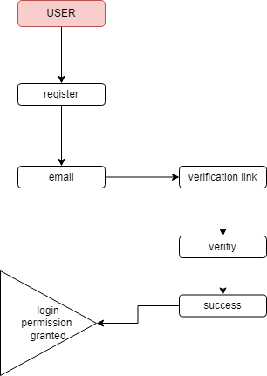

**DOCTOR**

**2.3 TECHNIQUES OR ALGORITHM:**

The telemedicine system for emergency dermatology care employs **Convolutional Neural Networks (CNNs)** to assist in the preliminary diagnosis of skin conditions. Patients can upload high-resolution images of their skin issues, which are processed by trained CNN models such as MobileNet or EfficientNet. These models, often enhanced through **transfer learning**, are capable of classifying a range of dermatological conditions with high accuracy, enabling dermatologists to make quicker and more informed decisions during consultations. This use of AI not only accelerates the diagnostic process but also reduces the burden on specialists during emergencies.

To ensure **data privacy and security**, the system incorporates the **Advanced Encryption Standard (AES)** to encrypt all sensitive information—such as personal data, medical records, and consultation images—before it is stored or transmitted. For real-time interactions, such as chat or video consultations, **end-to-end encryption protocols** (like TLS or Signal Protocol) are implemented to prevent data interception and unauthorized access. Additionally, the use of **two-factor authentication (2FA)** adds an extra layer of protection to user accounts, ensuring that only verified users can access confidential healthcare information.

The application also integrates a **smart triage algorithm** that uses a priority queue-based system to evaluate the urgency of incoming patient cases. This enables the platform to automatically prioritize severe or emergency cases for faster dermatologist response. A **cloud-based backend with Role-Based Access Control (RBAC)** manages user permissions, allowing patients, dermatologists, and administrators to securely access and manage only the data relevant to their roles. Furthermore, all user activities are logged via a **secure audit trail**, providing transparency and accountability, and reinforcing the platform’s commitment to ethical and secure healthcare delivery.

**CHAPTER 3**

**REQUIREMENTS**

**3.1 GENERAL:**

To successfully design, develop, and implement the project, certain foundational tools, technologies, and software environments are essential. These general requirements outline the minimum setup necessary for ensuring the project’s smooth execution and functionality. Without meeting these prerequisites, the development process cannot proceed efficiently or may result in system incompatibility, functionality issues, or performance bottlenecks.

The general requirements are divided into three major categories:

**3.2 HARDWARE REQUIREMENTS**

* PROCESSOR : GREATER THAN I3
* RAM : 4 GB DD RAM
* HARD DISK : 1 TB

**3.3 SOFTWARE REQUIREMENTS**

* FRAMEWORK : FLUTTER
* OPERATING SYSTEM : WINDOWS 10
* IDE : ANDROID STUDIO
* DATABASE : FIREBASE

**CHAPTER 4**

**SYSTEM DESIGN**

**4.1 GENERAL:**

Design Engineering deals with the various UML [Unified Modelling language] diagrams for the implementation of project. Design is a meaningful engineering representation of a thing that is to be built. Software design is a process through which the requirements are translated into representation of the software. Design is the place where quality is rendered in software engineering. Design is the means to accurately translate customer requirements into finished product.

**4.1.1 USECASE DIAGRAM:**

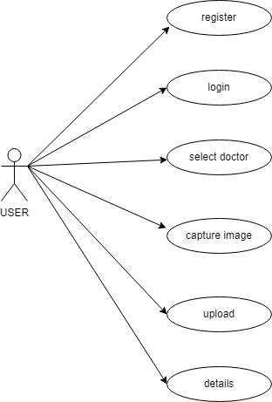

**EXPLANATION:**

The use case diagram is the main building block of object oriented modeling. It is used both for general conceptual modeling of the systematic of the application, and for detailed modeling translating the models into programming code. For this in our component diagram first propose a data In this proposed method we are using Hash-Solomon Code Algorithm to encrypt the data.

**4.1.2 STATE DIAGRAM:**

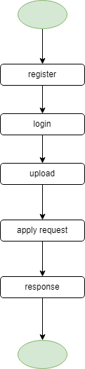

**EXPLANATION:**

State diagrams require that the system described is composed of a finite number of states; sometimes, this is indeed the case, while at other times this is a reasonable abstraction. Many forms of state diagrams exist, which differ slightly and have different semantics. In our state diagram first propose a . For this in our component diagram first propose a data In this proposed method we are using Hash-Solomon Code Algorithm to encrypt the data.

**4.1.3 ACTIVITY DIAGRAM:**

**EXPLANATION:**

Activity diagram are a loosely defined diagram to show workflows of stepwise activities and actions, with support for choice, iteration and concurrency. UML, activity diagrams can be used to describe the business and operational step-by-step workflows of components in a system. UML activity diagrams could potentially model the internal logic of a complex operation. In many ways UML activity diagrams are the object-oriented equivalent of flow charts and data flow diagrams (DFDs)from structural development.

**4.1.4 DATAFLOW DIAGRAM:**

**LEVEL 0:**

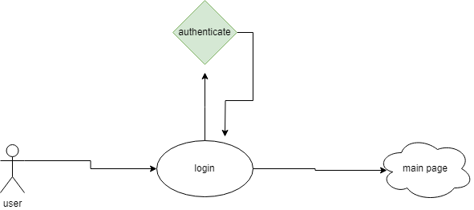

**LEVEL 1:**

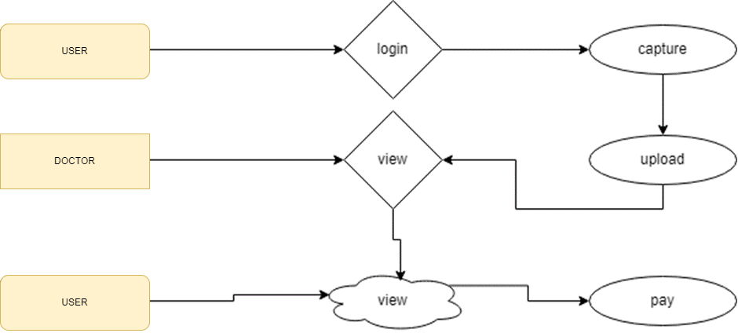

**LEVEL 2:**

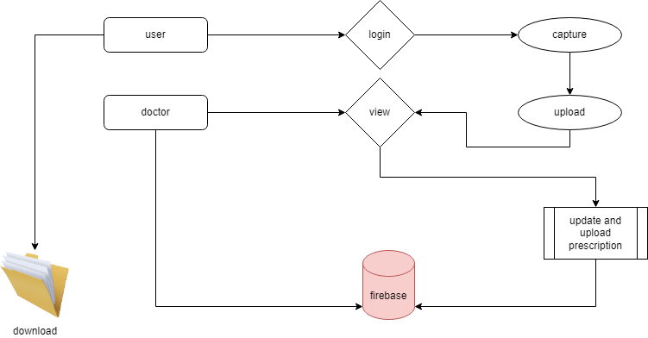

**EXPLANATION:**

A data flow diagram (DFD) is a graphical representation of the “flow” of data through an information system. It differs from the flowchart as it shows the data flow instead of the control flow of the program. A data flow diagram can also be used for the visualization of data processing. The DFD is designed to show how a system is divided into smaller portions and to highlight the flow of data between those parts.

**4.1.5 E-R DIAGRAM:**

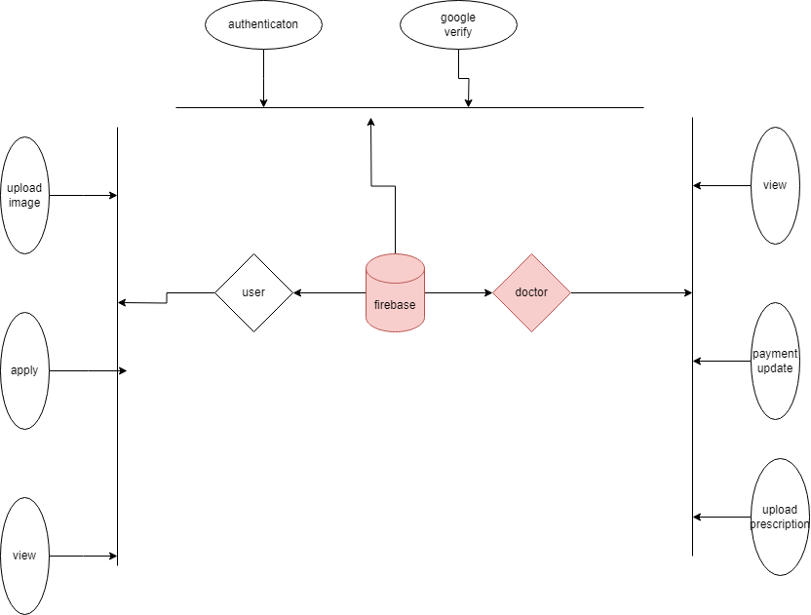

**EXPLANATION:**

An entity is represented as rectangle in an ER diagram. For example: In the following ER diagram we have two entities Student and College and these two entities have many to one relationship as many students study in a single college. We will read more about relationships later, for now focus on entities.

**4.1.6 SYSTEM ARCHITECTURE:**

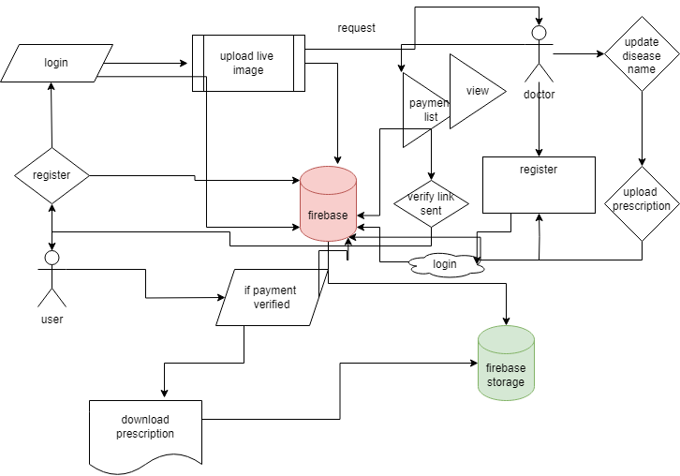

**EXPLANATION:**

The systems architect establishes the basic structure of the system, we propose a Hash code Solomon algorithm and we can put a small part of data in local machine and fog server in order to protect the privacy. Moreover, based on computational intelligence, this algorithm can compute the distribution proportion stored in cloud, fog, and local machine, respectively. Through the theoretical safety analysis and experimental evaluation, the feasibility of our scheme has been validated, which is really a powerful supplement to existing cloud storage scheme.

**CHAPTER 5**

**SOFTWARE SPECIFICATION**

**5.1 GENERAL:**

This chapter is about the software language and the tools used in the development of the project. The platform used here is JAVA. The Primary languages are JAVA, J2EE and J2ME. In this project J2EE is chosen for implementation.

**5.2 LAYOUT:**

The proposed telemedicine application features an intuitive **user interface layout** designed for ease of use by both patients and dermatologists during emergency consultations. The patient interface allows users to register, log in, upload high-resolution images of skin conditions, and request consultations. Dermatologists have a separate interface where they can access queued cases, view patient images, and provide feedback or prescriptions. An administrator panel is included to manage registrations, verify specialists, and oversee system operations. The layout ensures a clean, responsive design for smooth navigation across various mobile devices and screen sizes.

The **functional layout** defines the operational flow of the system. After logging in, patients can submit dermatological complaints along with images, which are processed by an integrated AI model to suggest a possible diagnosis. These cases are then prioritized using a smart triage algorithm that highlights emergencies for faster response. Dermatologists receive alerts and can initiate real-time video consultations. Once a diagnosis is confirmed, a unique encrypted patient ID is generated and used for secure follow-ups or referrals. The system also includes secure messaging, prescription uploads, and follow-up scheduling to streamline the care process.

From a **system architecture layout** perspective, the application is built using a layered model for scalability and security. The front end is developed using technologies like Flutter or Kotlin, enabling seamless user interaction. The back end, powered by Spring Boot or Node.js, handles authentication, API services, and business logic. The AI layer, utilizing convolutional neural networks (CNNs), processes medical images to support early diagnosis. Patient data is securely stored in cloud databases such as Firebase or MySQL, with encryption protocols like AES ensuring data privacy. Role-based access and audit trails ensure that data is accessed responsibly and transparently.

**5.3 WIDGETS:**

XML stands for Extensible Markup Language. XML is a markup language much like HTML used to describe data. It is derived from Standard Generalized Markup Language(SGML). Basically, the XML tags are not predefined in XML. We need to implement and define the tags in XML. XML tags define the data and used to store and organize data. It’s easily scalable and simple to develop. In Android, the XML is used to implement UI-related data, and it’s a lightweight markup language that doesn’t make layout heavy. XML only contains tags, while implementing they need to be just invoked.

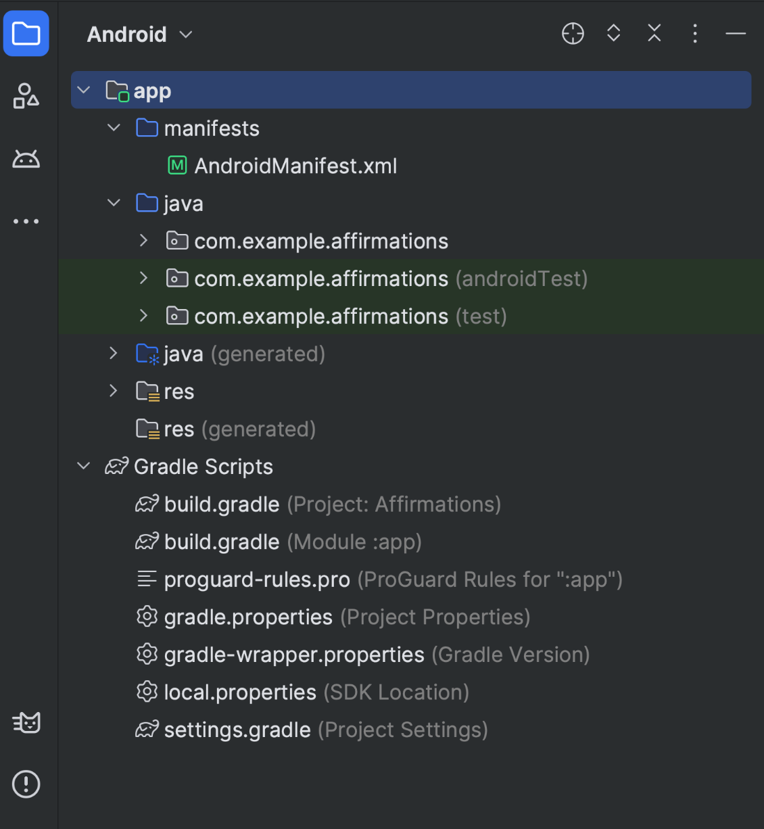

**Figure 1.** Project files in Android project view.

Each project in Android Studio contains one or more modules with source code files and resource files. The types of modules include:

* Android app modules
* Library modules
* Google App Engine modules

By default, Android Studio displays your project files in the Android project view, as shown in figure 1. This view is organized by modules to provide quick access to your project's key source files. All the build files are visible at the top level, under **Gradle Scripts**.

Each app module contains the following folders:

* **manifests**: Contains the AndroidManifest.xml file.

For more information, see Projects overview.

## Gradle build system

Android Studio uses Gradle as the foundation of the build system, with more Android-specific capabilities provided by the Android Gradle plugin. This build system runs as an integrated tool from the Android Studio menu and independently from the command line. You can use the features of the build system to do the following:

* Customize, configure, and extend the build process.
* Create multiple APKs for your app with different features, using the same project and modules.
* Reuse code and resources across source sets.

By employing the flexibility of Gradle, you can achieve all of this without modifying your app's core source files.

Android Studio build files are named build.gradle.kts if you use [Kotlin](https://kotlinlang.org/) (recommended) or build.gradle if you use Groovy. They are plain text files that use the Kotlin or Groovy syntax to configure the build with elements provided by the Android Gradle plugin. Each project has one top-level build file for the entire project and separate module-level build files for each module. When you import an existing project, Android Studio automatically generates the necessary build files.

**Note:** We might reference either the **build.gradle.kts** or **build.gradle** file alone in the documentation, but they're conceptually interchangeable. For example if you see **build.gradle.kts** but you use the Groovy DSL to configure your build, you can think of it as the **build.gradle** file (and the other way around).

To learn more about the build system and how to configure your build, see Configure your build.

### Build variants

The build system can help you create different versions of the same app from a single project. This is useful when you have both a free version and a paid version of your app or if you want to distribute multiple APKs for different device configurations on Google Play.

For more information about configuring build variants, see Configure build variants.

**5.4 FLUTTER:**

Flutter is an open-source UI software development toolkit created by Google. It is used to build natively compiled applications for mobile, web, and desktop from a single codebase. Flutter was first introduced in 2015 and has gained popularity for its ability to enable developers to create high-performance, visually appealing applications with a flexible and expressive user interface.

Here are key aspects of Flutter:

1. Single Codebase: Flutter allows developers to write code once and deploy it on multiple platforms, including iOS, Android, web, and desktop. This helps in reducing development time and effort.

2. Dart Programming Language: Flutter apps are primarily written in the Dart programming language. Dart is a modern, object-oriented language developed by Google. It is designed for building web, mobile, and desktop applications.

3.Widgets: Flutter uses a widget-based architecture for building user interfaces. Everything in Flutter is a widget, including structural elements like buttons and layout elements like rows and columns. Widgets are reusable and can be combined to create complex UIs.

4. Hot Reload: One of Flutter's most praised features is hot reload, which allows developers to instantly see the effect of code changes during development without restarting the entire application. This accelerates the development process and makes it easier to experiment with UI changes.

5. Rich Set of Pre-designed Widgets: Flutter comes with a rich set of pre-designed widgets for common UI elements, making it easier for developers to create consistent and attractive interfaces. Custom widgets can also be created to suit specific design requirements.

6. Material Design and Cupertino Styles: Flutter provides widgets that implement the Material Design guidelines for Android apps and the Cupertino style for iOS apps. This allows developers to create platform-specific designs while sharing most of the code.

7. Performance: Flutter compiles to native ARM code, providing high performance on both iOS and Android. The framework also includes a GPU-accelerated rendering engine, making it suitable for graphics-intensive applications.

8. Integration with Native Features: Flutter allows developers to integrate with native features and APIs of the underlying operating systems, providing access to device-specific capabilities.

9. Community and Ecosystem: Flutter has a growing and active community of developers who contribute to its ecosystem. There is a wide range of third-party packages and plugins available through Dart's package manager (pub.dev) that can be used to extend Flutter's functionality.

10. Web and Desktop Support: Flutter extends its platform support beyond mobile devices. It includes experimental support for building web applications and desktop applications for Windows, macOS, and Linux.

**5.5 Conclusion**

xml and layout are gaining rapid acceptance as means to provide dynamic content on the Internet. With full access to the Java platform, running from the server in a secure manner, the application possibilities are almost limitless. When JSPs are used with Enterprise JavaBeans technology, e-commerce and database resources can be further enhanced to meet an enterprise's needs for web applications providing secure transactions in an open platform. J2EE technology as a whole makes it easy to develop, deploy and use web server applications instead of mingling with other technologies such as CGI and ASP. There are many tools for facilitating quick web software development and to easily convert existing server-side technologies to JSP and Servlets.

**CHAPTER 6**

**IMPLEMENTATION**

* 1. **GENERAL:**

This chapter describes the implementation of searched based application. It deals with the source code for main viewpoint for Anonymous Database Management.

* 1. **CODINGS:**

import 'package:firebase_core/firebase_core.dart';

import 'package:flutter/material.dart';

import 'package:telemedicine/widgets/auth_gate.dart';

import 'package:telemedicine/widgets/auth_gate2.dart';

void main() async {

WidgetsFlutterBinding.ensureInitialized();

await Firebase.initializeApp();

runApp(MyApp());

}

class MyApp extends StatelessWidget {

@override

Widget build(BuildContext context) {

return MaterialApp(

home: SplashScreen(),

);

}

}

class SplashScreen extends StatelessWidget {

@override

Widget build(BuildContext context) {

return Scaffold(

body: Stack(

children: [

// Background Image

Image.asset(

'assets/images/wppp.jpg', // Replace with your image asset path

width: double.infinity,

height: double.infinity,

fit: BoxFit.cover,

),

// Fading Container

Container(

decoration: BoxDecoration(

gradient: LinearGradient(

begin: Alignment.topCenter,

end: Alignment.bottomCenter,

colors: [

Colors.transparent, // Fade from transparent

Colors.black.withOpacity(0.8), // to slightly opaque

],

),

),

child: Center(

child: Column(

mainAxisAlignment: MainAxisAlignment.center,

children: [

Text(

'Time Health...',

style: TextStyle(

fontSize: 35,

color: Colors.indigo,

fontWeight: FontWeight.w800, // Make it bold

fontStyle: FontStyle.italic, // Add italic style

// Add additional styling as needed

),

),

SizedBox(height: 30),

ElevatedButton(

onPressed: () {

Navigator.pushReplacement(

context,

MaterialPageRoute(builder: (context) => AuthGate()),

);

},

child: Text('Continue as User'),

),

SizedBox(height: 10),

ElevatedButton(

onPressed: () {

Navigator.pushReplacement(

context,

MaterialPageRoute(builder: (context) => AuthGate2()),

);

},

child: Text('Continue as Doctor'),

),

],

),

),

),

],

),

);

}

}

class CustomerScreen extends StatelessWidget {

@override

Widget build(BuildContext context) {

return Scaffold(

appBar: AppBar(

title: Text('Customer Page'),

),

body: Center(

child: Text('Welcome, Customer!'),

),

);

}

}

class AdminScreen extends StatelessWidget {

@override

Widget build(BuildContext context) {

return Scaffold(

appBar: AppBar(

title: Text('Admin Page'),

),

body: Center(

child: Text('Welcome, Admin!'),

),

);

}

}

import 'package:firebase_auth/firebase_auth.dart';

import 'package:flutter/cupertino.dart';

import 'package:flutter/material.dart';

import 'package:firebase_core/firebase_core.dart';

import 'package:firebase_database/firebase_database.dart';

import 'finallistpage.dart';

import 'fulllistviewpage.dart';

void main() async {

WidgetsFlutterBinding.ensureInitialized();

await Firebase.initializeApp();

runApp(vii());

}

class vii extends StatefulWidget {

const vii({super.key,});

@override

State<vii> createState() => _usrequState();

}

class da{

final String cname;

final String caddress;

final String cmobile;

final String clocation;

final String ckey;

final String cnkey;

final String date;

final String members;

final String naddress;

final String ngoname;

final String nkey;

final String nmobile;

final String nlocation;

da(this.cname, this.date,this.caddress,this.cmobile,this.clocation,

this.ngoname, this.cnkey,this.nkey,this.nmobile,this.nlocation,this.members,

this.ckey,this.naddress

);

}

class _usrequState extends State<vii> {

String authh = " ";

final DatabaseReference _databaseReference =

FirebaseDatabase.instance.reference().child('shedule');

List<> dataList = [];

@override

void initState() {

super.initState();

final FirebaseAuth _auth = FirebaseAuth.instance;

User? user = _auth.currentUser;

String? userId = user?.uid;

if (userId != null) {

setState(() {

authh = userId;

}); // Construct the path in the Realtime Database using the userId

// Fetch data from the Realtime Database

}

}

@override

Widget build(BuildContext context) {

return Scaffold(

body: _buildListViewWithDivider(),

);

}

Widget _buildListViewWithDivider() {

return StreamBuilder(

stream: _databaseReference

.orderByChild('pkey')

.equalTo(authh)

.onValue,

builder: (context, snapshot) {

if (snapshot.connectionState == ConnectionState.waiting) {

return Center(

child: CircularProgressIndicator(),

);

} else if (snapshot.hasError) {

return Center(

child: Text('Error loading requests.'),

);

} else if (!snapshot.hasData || snapshot.data?.snapshot.value == null) {

return Center(

child: Text('No Requests.'),

);

} else {

Map<String, dynamic> data =

Map<String, dynamic>.from(snapshot.data!.snapshot.value as Map);

List<String> itemIds = data.keys.toList();

return ListView.builder(

itemCount: itemIds.length * 2 - 1, // Add dividers

itemBuilder: (context, index) {

if (index.isOdd) {

// Divider

return Divider();

} else {

// Item

int itemIndex = index ~/ 2;

String itemId = itemIds[itemIndex];

String mname = data[itemId]['mname']?.toString() ?? '';

String pname = data[itemId]['pname']?.toString() ?? '';

// List<String> dateArray = date.split(' ');

// Now dateArray contains the parts of the date split by space

// print('First part of the date: ${dateArray[0]}');

// String datefinal=dateArray[0];

String dosage = data[itemId]['dosage']?.toString() ?? '';

String category = data[itemId]['category']?.toString() ?? '';

String pkey = data[itemId]['pkey']?.toString() ?? '';

return Card(

elevation: 5,

margin: EdgeInsets.all(20),

color: Colors.blueGrey, // Set the card color here

child: Padding(

padding: EdgeInsets.all(10),

child: ListTile(

title: Text(

pname,

style: TextStyle(

color: Colors.black45, // Set title text color here

fontWeight: FontWeight.bold,fontSize: 18,

),

),

subtitle: Column(

crossAxisAlignment: CrossAxisAlignment.start,

children: [

Text(

'Medicine name: $mname',

style: TextStyle(color: Colors

.white), // Set date text color here

),

Text(

'Category: $category',

style: TextStyle(color: Colors

.white), // Set time text color here

),

Text(

'Dosage: $dosage',

style: TextStyle(color: Colors

.white), // Set address text color here

),

],

),

**CHATPTER 7**

**SNAPSHOTS**

**7.1 GENERAL:**

This section presents a series of snapshots illustrating the key features and user interfaces of the Secure Healthcare Management System developed using blockchain technology. The snapshots provide a visual representation of how the system functions from both the patient and healthcare provider perspectives.

**7.2 SNAPSHOTS:**

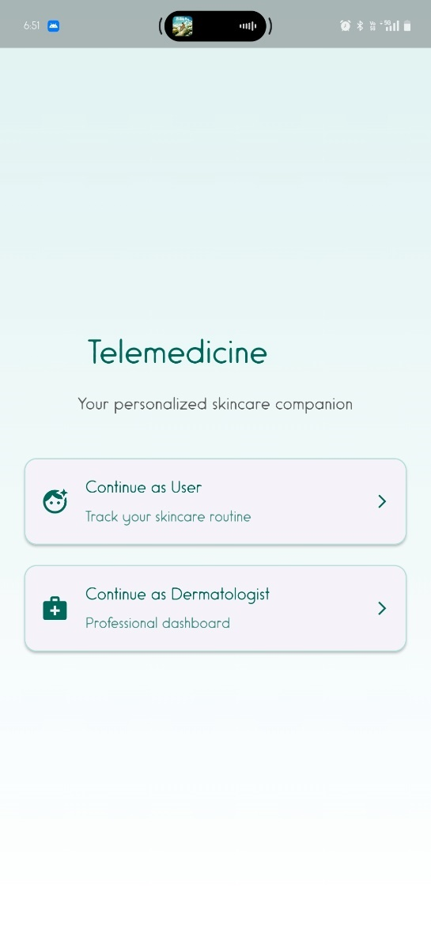

**CHAPTER 8**

**SOFTWARE TESTING**

**8.1 FIREBASE:**

**Firebase** is a Backend-as-a-Service (Baas). It provides developers with a variety of tools and services to help them develop quality apps, grow their user base, and earn profit. It is built on Google’s infrastructure.

Firebase is categorized as a [NoSQL](https://www.educative.io/edpresso/whats-the-difference-betweensql-and-nosql) database program, which stores data in JSON-like documents.



In Firebase, a document is a set of key-value pairs defined by a schema. A group of documents makes up a collection.

## **Key Features:**

### **1. Authentication**

It supports authentication using passwords, phone numbers, Google, Facebook, Twitter, and more. The Firebase Authentication (SDK) can be used to manually integrate one or more sign-in methods into an app.

### **2. Realtime database**

Data is synced across all clients in realtime and remains available even when an app goes offline.

### **3. Hosting**

Firebase Hosting provides fast hosting for a web app; content is cached into content delivery networks worldwide.

### **4. Test lab**

The application is tested on virtual and physical devices located in Google’s data centers.

### **5. Notifications**

Notifications can be sent with firebase with no additional coding.

Users can get started with firebase for free; more details can be found on the [official website](https://firebase.google.com/).

**8.2 SOFTWARE TESTING:**

**8.2.1 FEASIBILITY STUDY:**

Feasibility studies aim to objectively and rationally uncover the strengths and weaknesses of the existing business or proposed venture, opportunities and threats as presented by the environment, the resources required to carry through, and ultimately the prospects for success.

In its simplest term, the two criteria to judge feasibility are cost required and value to be attained. As such, a well-designed feasibility study should provide a historical background of the business or project, description of the product or service, accounting statements, details of the operations and management, marketing research and policies, financial data, legal requirements and tax obligations. Generally, feasibility studies precede technical development and project implementation.

They are 3 types of Feasibility

* Economical feasibility
* Technical feasibility
* Operational feasibility

**8.2.1.1 ECONOMICAL FEASIBILITY:**

The assessment is based on an outline design of system requirements in terms of Input, Processes, Output, Fields, Programs, and Procedures. This can be quantified in terms of volumes of data, trends, frequency of updating, etc. to estimate whether the new system will perform adequately or not.

**8.2.1.2 TECHNICAL FEASIBILITY:**

This study is carried out to check the technical feasibility, that is, the technical requirements of the system. Any system developed must not have a high demand for the available technical resources.

**8.2.1.3 OPERATIONAL FEASIBILITY:**

The aspect of study is to check the level of acceptance of the system by the user. This includes the process of training the user to use the system efficiently. The user must not feel threatened by the system, instead must accept it as a necessity.

**8.3 SYSTEM TESTING:**

The software which has been developed, has to be tested to prove its validity. Testing is the least creative phase of the whole cycle of system design. In the real sense it is the phase which helps to bring out the creativity of the other phases makes it shine.

**8.3.1. VARIOUS LEVELS OF TESTING:**

1. White Box Testing

2. Black Box Testing

3. Unit Testing

4. Functional Testing

5. Performance Testing

6. Integration Testing

7. Validation Testing

8. System Testing

9. Output Testing

10. User Acceptance Testing

**8.3.1.1. WHITE BOX TESTING:**

White-box testing, sometimes called glass-box, is a test case design method that uses the control structure of the procedural design to derive test cases. Using White Box testing methods, we can derive test cases that

• Guarantee that all independent paths within a module have been exercised at least once

• Exercise all logical decisions on their true and false sides.

• Execute all loops at their boundaries and within their operational bounds.

• Exercise internal data structures to assure their validity.

**8.3.1.2. BLACK BOX TESTING:**

Black Box Testing is testing the software without any knowledge of the inner workings, structure or language of the module being tested. Black box tests, like most other kinds of tests, must be written from a definitive source document, such as specification or requirements document, such as specification or requirements document. It is a test in which the software under the test is treated as a black box. You cannot “see” into it. The test provides input and responds to outputs without considering how the software works.

In this testing by knowing the internal operation of a product, test can be conducted to ensure that “all gears mesh”, that is the internal operation performs according to specification and all internal components have been adequately exercised. It fundamentally focuses on the functional requirements of the software.

**8.3.1.3. UNIT TESTING:**

Unit testing is a method by which individual units of source code, sets of one or more computer program modules together with associated control data, usage procedures, and operating procedures are tested to determine if they are fit for use. Intuitively, one can view a unit as the smallest testable part of an application. In procedural programming, a unit could be an entire module, but it is more commonly an individual function or procedure. In object-oriented programming, a unit is often an entire interface, such as a class, but could be an individual method. Unit tests are short code fragments created by programmers or occasionally by white box testers during the development process.

Unit testing is software verification and validation method in which the individual units of source code are tested fit for use. A unit is the smallest testable part of an application. In this testing, each class is tested to be working satisfactorily.

Unit testing involves the design of test cases that validate that the internal program logic is functioning properly, and that program inputs produce valid outputs. All decision branches and internal code flow should be validated. It is the testing of individual software units of the application. it is done after the completion of an individual unit before integration.

**8.3.1.4. FUNCTIONAL TESTING:**

Functional testing is a quality assurance (QA) process and a type of black box testing that bases its test cases on the specifications of the software component under test. Functions are tested by feeding them input and examining the output, and internal program structure is rarely considered (not like in white-box testing). Functional Testing usually describes what the system does. Functional testing differs from system testing in that functional testing "verifies a program by checking it against ... design document(s) or specification(s)", while system testing "validate a program by checking it against the published user or system requirements" (Kane, Falk, Nguyen 1999, p. 52). Functional testing typically involves five steps. The identification of functions that the software is expected to perform

1. The creation of input data based on the function's specifications

2. The determination of output based on the function's specifications

3. The execution of the test case

4. The comparison of actual and expected outputs.

**8.3.1.5. PERFORMANCE TESTING:**

In general testing is performed to determine how a system performs in terms of responsiveness and stability under a particular workload. It can also serve to investigate, measure, validate or verify other quality attributes of the system, such as scalability, reliability and resource usage.

Performance testing is a subset of performance engineering, an emerging computer science practice which strives to build performance into the implementation, design and architecture of a system.

**8.3.1.6. INTEGRATION TESTING:**

Integration testing is a systematic technique for constructing the program structure while at the same time conducting tests to uncover errors associated with. Individual modules, which are highly prone to interface errors, should not be assumed to work instantly when put together. The problem of course, is “putting them together”- interfacing. There may be the chances of data loss across on another’s sub functions, when combined may not produce the desired major function; individually acceptable impression may be magnified to unacceptable levels; global data structures can present problems.

Integration testing is the phase in software testing in which individual software modules are combined and tested as a group. Integration testing takes as its input modules that have been unit tested, groups them in larger aggregates, applies tests defined in an integration test plan to those aggregates, and delivers as its output the integrated system ready. All the errors found in the system are corrected for the next phase.

The purpose of integration testing is to verify functional, performance, and reliability requirements placed on major design items. These "design items", i.e. assemblages (or groups of units), are exercised through their interfaces using black box testing, success and error cases being simulated via appropriate parameter and data inputs. Simulated usage of shared data areas and inter-process communication is tested, and individual subsystems are exercised through their input interface. Test cases are constructed to test whether all the components within assemblages interact correctly, for example across procedure calls or process activations, and this is done after testing individual modules, i.e. unit testing.

**8.3.1.7. VALIDATION TESTING:**

Verification and Validation are independent procedures that are used together for checking that a product, service, or system meets requirements and specifications and that it full fills its intended purpose. These are critical components of a quality management system such as ISO 9000. The words "verification" and "validation" are sometimes preceded with "Independent" (or IV&V), indicating that the verification and validation is to be performed by a disinterested third party.

It is sometimes said that validation can be expressed by the query "Are you building the right thing?" and verification by "Are you building it right?". In practice, the usage of these terms varies. Sometimes they are even used interchangeably.

**8.3.1.8. SYSTEM TESTING:**

System testing of software or hardware is testing conducted on a complete, integrated system to evaluate the system's compliance with its specified requirements. System testing falls within the scope of black box testing, and as such, should require no knowledge of the inner design of the code or logic. As a rule, system testing takes, as its input, all the "integrated" software components that have passed integration testing and the software system itself integrated with any applicable hardware system(s). The purpose of integration testing is to detect any inconsistencies between the software units that are integrated together (called *assemblages*) or between any of the *assemblages* and the hardware. System testing is a more limited type of testing; it seeks to detect defects both within the "inter-assemblages" and within the system as a whole.

System testing is performed on the entire system in the context of a Functional Requirement Specification(s) (FRS) and/or a System Requirement Specification (SRS). System testing tests not only the design, but also the behaviour and even the believed expectations of the customer. It is also intended to test up to and beyond the bounds defined in the software/hardware requirements specification.

**8.3.1.9. OUTPUT TESTING:**

After performing the validation testing, the next step is output testing of the proposed system since no system could be useful if it does not produce the required output generated or considered into two ways. One is on screen and another is printed format. The output comes as the specified requirements by the user. Hence output testing does not result in any correction in the system.

**8.3.1.10. USER ACCEPTANCE TESTING:**

User acceptance of a system is the factor for the success of any system. The system under consideration is tested for the user acceptance by constantly keeping in touch with the prospective system users at the time of developing and making changes wherever required.

• Input screen design.

• Output screen design.

• Online message to guide users.

• Format of the ad-hoc reports and other outputs.

Taking various kinds of test data does the above testing. Preparation of test data plays a vital role in system testing. After preparing the test data the system under study is tested using the test data. While testing the system by using test data errors are again uncovered and correct.

**CHAPTER 9**

**APPLICATION AND FUTURE ENHANCEMENT**

**9.1 GENERAL:**

The proposed telemedicine system for emergency dermatology care revolutionizes how patients and dermatologists interact during time-critical situations. By leveraging mobile technology, AI, and secure communication protocols, the system provides a fast, reliable, and confidential platform for diagnosing and treating skin conditions remotely. This approach reduces the need for physical visits in emergencies, ensuring timely intervention while preserving the integrity of sensitive health data. The application design supports encrypted data transmission, user authentication, and intelligent triage, improving the speed and accuracy of care delivery.

**9.2 APPLICATIONS:**

This consult-based mobile telemedicine system can be applied in a variety of practical scenarios:

* **Emergency Dermatology Services:** Enables rapid diagnosis and care in remote or rural areas where dermatologists are not easily accessible.
* **Hospitals and Clinics:** Assists in pre-screening dermatological emergencies and prioritizing critical patients for in-person care.
* **Disaster Relief and Military Camps:** Supports dermatological assessment in field hospitals or disaster-stricken zones where immediate care is crucial.
* **Public Health Outreach:** Helps dermatology departments conduct remote skin health camps and awareness programs via mobile consultations.
* **School and Corporate Health Programs:** Facilitates preventive skin health checks through quick consultations for early detection of conditions like infections or allergies.
* **Insurance and Medical Documentation:** Stores encrypted images and diagnostic data for claims, follow-ups, and legal compliance.

**9.3 FUTURE ENHANCEMENTS:**

To scale and strengthen the application further, several enhancements can be incorporated:

* **AI-Based Skin Analysis:** Integrate advanced machine learning models for auto-diagnosing conditions based on image patterns and previous cases.
* **Real-Time Video Consultation:** Improve user experience with HD video calls, supported by low-latency streaming protocols and automatic bandwidth adjustment.
* **Blockchain Integration:** Secure patient data using blockchain to ensure transparency, immutability, and controlled access via smart contracts.
* **Cross-Specialist Collaboration:** Allow other specialists (e.g., allergists, general physicians) to consult and co-manage patient cases within the same platform.
* **Offline Data Capture:** Enable offline consultation support for remote locations with delayed data sync when internet is restored.
* **Wearable Integration:** Connect with skin health monitoring devices or mobile dermatoscopes for real-time, enhanced diagnostic data.

**CHAPTER 10**

**CONCLUSION & REFERENCES**

**10.1 CONCLUSION:**

In conclusion, the development of the telemedicine consult mobile application for emergency dermatology care represents a significant advancement in delivering timely and accessible healthcare services, particularly in remote and underserved regions. By integrating real-time consultations, secure image sharing, and intelligent triage mechanisms, the system bridges the gap between patients and dermatologists during critical situations. It empowers healthcare providers to respond swiftly to dermatological emergencies, reducing the burden on traditional healthcare infrastructure while improving patient outcomes. The use of encryption and role-based access ensures the confidentiality and integrity of sensitive medical data, fostering trust among users. The application also paves the way for scalable healthcare solutions by incorporating technologies such as artificial intelligence, mobile health, and cloud storage. Its flexible architecture supports further enhancements like AI-driven diagnostics, wearable device integration, and blockchain-based security, making it a future-ready platform for dermatological care. Additionally, the mobile-first approach increases the system’s reach and usability, enabling individuals to seek expert consultation from anywhere at any time. Overall, this project demonstrates the potential of digital health technologies to transform emergency dermatology care by making it more efficient, secure, and patient-centric. With continuous improvement and adoption, this system can contribute significantly to the broader vision of accessible and equitable healthcare for all.

**10.2 REFERENCES:**

1. S. Gençoğlu, "Analysis of Skin Health Management Through Telemedicine and Mobile Health in Dermatology in the Post-COVID Era," *European Research Journal*, vol. 10, no. 3, pp. 123–130, Jul. 2024.[ResearchGate](https://www.researchgate.net/publication/382451324_Analysis_of_skin_health_management_through_telemedicine_and_mobile_health_in_dermatology_in_the_post-COVID_era?utm_source=chatgpt.com)
2. D. Zama et al., "Perspectives and Challenges of Telemedicine and Artificial Intelligence in Pediatric Dermatology," *Children*, vol. 11, no. 11, p. 1401, Nov. 2024.[MDPI](https://www.mdpi.com/2227-9067/11/11/1401?utm_source=chatgpt.com)
3. J. Zhou et al., "SkinGPT-4: An Interactive Dermatology Diagnostic System with Visual Large Language Model," *arXiv preprint arXiv:2304.10691*, Apr. 2023.[arXiv](https://arxiv.org/abs/2304.10691?utm_source=chatgpt.com)
4. D. P. Panagoulias et al., "Dermacen Analytica: A Novel Methodology Integrating Multi-Modal Large Language Models with Machine Learning in Tele-Dermatology," *arXiv preprint arXiv:2403.14243*, Mar. 2024.[arXiv](https://arxiv.org/abs/2403.14243?utm_source=chatgpt.com)
5. L. V. Maul et al., "Acceptance of Telemedicine Compared to In-Person Consultation From the Providers' and Users’ Perspectives: Multicenter, Cross-Sectional Study in Dermatology," *JMIR Dermatology*, vol. 3, no. 1, p. e45384, Jan. 2023.[JDerm](https://derma.jmir.org/2023/1/e45384/?utm_source=chatgpt.com)
6. A. Börve et al., "Smartphone Teledermoscopy Referrals: A Novel Process for Improved Triage of Skin Cancer Patients," *Acta Dermato-Venereologica*, vol. 95, no. 2, pp. 186–190, Feb. 2015.[Wikipedia](https://en.wikipedia.org/wiki/First_Derm?utm_source=chatgpt.com)
7. U. Kalwa et al., "Skin Cancer Diagnostics with an All-Inclusive Smartphone Application," *arXiv preprint arXiv:2205.12438*, May 2022.[arXiv](https://arxiv.org/abs/2205.12438?utm_source=chatgpt.com)
8. R. Jalaboi et al., "Explainable Image Quality Assessments in Teledermatological Photography," *arXiv preprint arXiv:2209.04699*, Sep. 2022.[arXiv](https://arxiv.org/abs/2209.04699?utm_source=chatgpt.com)
9. S. Nakamoto, "Bitcoin: A Peer-to-Peer Electronic Cash System," 2008. [Online]. Available: <https://bitcoin.org/bitcoin.pdf>
10. M. A. Ferrag et al., "Blockchain Technologies for the Internet of Things: Research Issues and Challenges," *IEEE Internet of Things Journal*, vol. 6, no. 2, pp. 2188–2204, Apr. 2019.